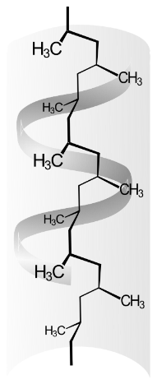
2. a. Polymers – Advantages and Disadvantages

Polypropylene
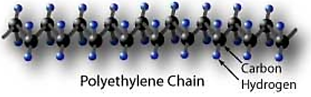
Polymers are often called macromolecules because they can be very, very large and made from millions of atoms. Polymers are made by joining many thousands of smaller molecules together. The smaller molecules are called monomers and polymerisation is the process where new covalent bonds are formed between the monomers to create a polymer. Often there are only one, or two monomers used, so a polymer is generally a small structured arrangement of atoms, repeated again and again and again.

There are many naturally occurring polymers, including proteins, carbohydrates, and fats. Many polymers have been synthesised because polymers can offer a unique and combination of physical and chemical properties which are useful to humans. However these physical and chemical properties may also be considered detrimental when a broader view of the polymer is considered. An example of this is the durability of polyethylene. This an advantage because it maintains its physical and chemical properties for many years without degrading. However it is also a disadvantage because this material does not readily biodegrade, creating a pollution problem which persists for a very long time.
TASK: use the Information attached to the sheet to complete the table below. The table requires you to discuss the advantages and Disadvantages of polymer use (SC 56), in terms of strength, density, lack of reactivity, use of natural resources, and biodegradability. This is the exact wording of SC 56 – not a lot of detail is required(cognitive verb is “discuss”), often 1 sentence is sufficient, maybe two sentences max. Some ads and disads may be repeated.
Property of polymers | Advantages | Disadvantages
STRENGTH
DENSITY
LACK OF REACTIVITY
USE OF NATURAL RESOURCES
BIODEGRADABILITY

Advantages and Disadvantages Of Polymers

The advantages of polymers
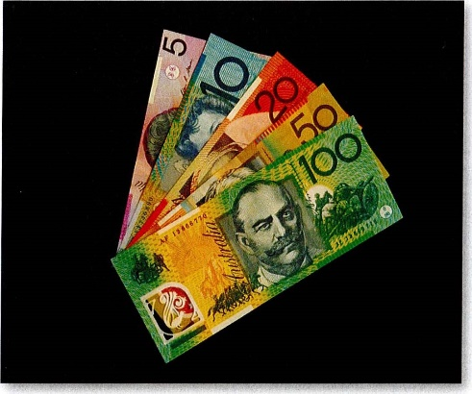
One advantage of polymers is the flexibility and enormous variety of their structure and properties. They can be solid structures or thin films. Some can be used as insulators (heat and electricity), others as conductors. Some are transparent and can be used for windows and lenses, whereas others are opaque. These can vary depending on the monomers used, the conditions of manufacture and additives employed. Many polymers are relatively cheap, strong and durable. They have low density, which means they are economical to transport, using less fuel in the process. They are easy to manufacture and do not need maintenance such as painting.
Many polymers have advantages over traditional materials such as glass, metals and ceramics including lower costs and lower density. Also bank notes made from polymers such as polyethene are more durable and make counterfeiting more difficult.

Figure 80.1 Polymer banknotes.
Polymers provide the ability to design and manufacture substances suitable for particular jobs and some technology such as wind power would not be possible without polymers.
- Polymer based sprays have been developed to improve the penetration of water into soils. These are of particular use in Australia as up to thirty per cent of Australia's cropping land is water repellent making it difficult to farm crops.
- Capsules have been developed to cover thin film solar cells and protect them from water and oxygen, thus allowing them to last longer in our harsh Australian climate.
- Fabrics that 'breathe' have been developed from polymers such as Teflon.
- Hydrogels have been developed to be used as devices to deliver drugs to nerve cells during stroke, spinal cord injury and traumatic brain injury. Polymers have been synthesised that mimic biological molecules - with similar properties to those of proteins and RNA allowing scientists to study how natural biopolymers fold.

The disadvantages of polymers
One advantage of polymers is that they last so long -they are unreactive. However, this is also a disadvantage as they are difficult to dispose of. They do not decompose, take up a lot of space in landfill, and if you bum them they produce toxic gases such as dioxins and the greenhouse gas carbon dioxide. Many polymers can be recycled, but separating them out is difficult and expensive.
There are moves to solve this problem. Polymers are being produced which are biodegradable, and bags made of these polymers are available. They decompose to carbon dioxide - a greenhouse gas. However, if these are buried in landfill where no oxygen is available, they will decompose to methane a more potent greenhouse gas than carbon dioxide. Also water soluble polymers have been developed for some packaging.
There are still problems such as their pollutant effect on the ocean including the effect of discarded plastic bags on marine life
Polymers are also using up a non-renewable resource petroleum. We need to consider if this is an acceptable way to use this resource and whether or not it is sustainable.
Another problem is the toxicity of many raw materials used to make polymers, exposing workers to risk in factories and the risk of leaks that can affect the environment and the general public. It has now also been found that some toxic substances such as bisphenols can leach out of polymers during use.
For example, the comonomers used in the synthesis of PVA (polyvinyl alcohol) include acrylamide, a neurotoxin; formaldehyde, a suspected carcinogen which also causes mutations; and vinyl chloride a carcinogen. The cross-linkage agent is also highly toxic causing burning effects similar to those of mustard gas.

Properties of polymers
Strength
In general, increasing the chain length of a polymer increases its strength and toughness. This is because van der Waals attractions and entanglements increase as chains get longer. These interactions reduce movement within and between individual chains, increasing resistance to deformation or breakage.
Many materials that were once commonly used have been replaced with polymers because they are stronger. For example, in aircraft and aquariums, glass has been replaced by polymethyl methacrylate (Figure 2), a transparent, shatter-resistant, strong polymer. Common names for this material are Perspex® and Plexiglas.
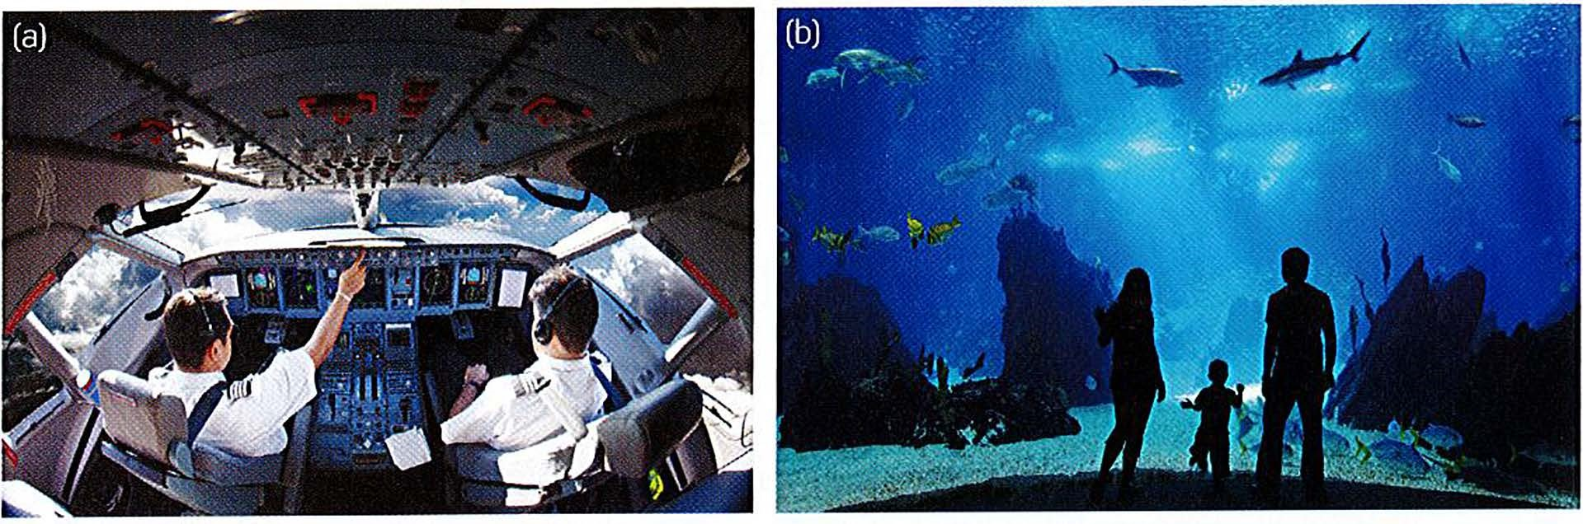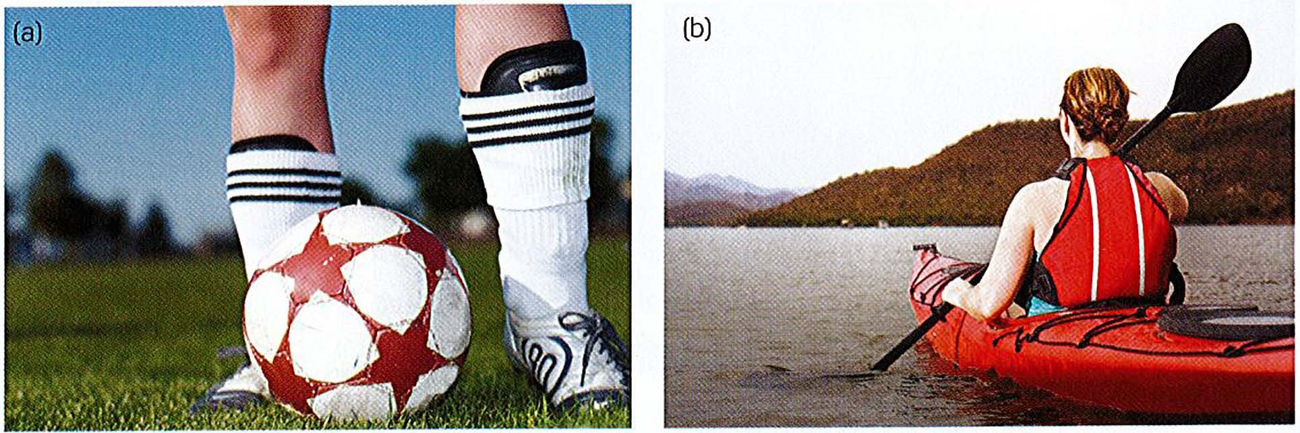

Density
The densities of polymers vary greatly. A lot of sport equipment needs to be strong, flexible and light; for example, shin pads and kayaks (Figure 3).
Low-density polymers are still relatively strong. In Figure 4, you can see that polymers
(and composites) have very low density for their strength. For example, polymers have a similar strength to many metals and alloys, but they are less dense. They have a similar strength to wood, but are not susceptible to weather damage and do not decompose over time.

Lack of reactivity
Polymers are the preferred material for many applications because of their lack of reactivity. Unlike iron and its alloys, polymers do not rust, so are resistant to corrosion. This makes them useful in the aerospace, automotive, electronics and energy industries. In the field of electronics, polymers are used as insulators and semiconductors.
Use of natural resources and biodegradability
Most polymers are non-biodegradable. In the 1980s, the environmental challenges posed by polymers led to increased interest in biodegradable polymers. Most biodegradable polymers are condensation polymers from renewable sources such as plants; for example, corn starch. Biodegradable polymers have similar structures to biological macromolecules, such as carbohydrates or proteins. The similar structure enables them to break down much faster than synthetic polymers.
One biodegradable polymer is polylactic acid, also known as polylactide (PLA). PLA is a bioactive thermoplastic made from renewable resources. It is used in biodegradable cups, medical applications and 3D printers (Figure 5). PLA is broken down into naturally occurring lactic acid monomers by microorganisms.
Scientists are very interested in the prospect of biodegradation of common polymers such as polyurethane. It has been found that Pestalotiopsis microspore, a fungus, breaks down and digests polyurethane. The fungus is found in fallen foliage of common ivy in Buenos Aires, Argentina. Other microorganisms, such as Enterobacter asburiae YT 1 and Bacillus sp. YP 1, can break down polyethene. Some scientists even suggest that microorganisms are now evolving to have genes capable of breaking down plastics, since the appearance of the plastisphere. Plastispheres are ecosystems which have evolved to live in plastic contaminated enviroments.

Stability and biodegradability
Most of the bonds in pol_{ym}ers are strong covalent C-C and C-H bonds, so the pol_{ym}ers are fairly stable. This means that most synthetic pol_{ym}ers, unlike natural pol_{ym}ers, are not biodegradable.
However, PVC has C-Cl bonds, which are weaker than C-H bonds, and are broken by ultraviolet light. The pol_{ym}er becomes brittle and cracked if it has been in sunlight for some time. Special additives, called stabilisers, are added to the pol_{ym}er to protect it from degradation.
To increase the biodegradability of synthetic pol_{ym}ers, chemists have copol_{ym}erised them with natural pol_{ym}er segments, such as those in starch. This causes the pol_{ym}er chain to break down into many smaller segments.

Disadvantages of polymer use
Synthetic pol_{ym}ers, usually referred to as plastics, are fundamental to our lifestyle. They are found in packaging, adhesives, clothes, medical devices and so many other materials that it would be impossible to list them all. These materials have revolutionised sports equipment and been responsible for major advances in electronic technology. The amount of pol_{ym}ers used in the aviation industry has doubled in the last decade because they can be engineered to offer strength and lightness.
From an early age, we have been surrounded by plastic: plastic toys, plastic containers, plastic bags, even non-stick coating on pans, chewing gum and Lycra in clothes. The development of plastics has only occurred in the last 70 years or so and they have only been used on a massive scale over the last 60 years.
Plastics are amazing materials; they come in every shape, size and colour, and with every material property you could think of: strong, flexible, elastic, hard, ductile, transparent, slippery, brittle, to name a few. As chemists develop new plastics, the variety of properties and uses expand dramatically.
However, the widespread distribution and use of plastics has not been without cost. There are two main problems that need to be considered as plastic use continues to escalate. One is what to do with plastic articles after we have finished using them and the other is to find a new source of the raw material of plastic manufacture as the current one runs out.

